**Table of Contents**

1 Objective of This Experiment 3

2 The Buck Converter 3

2.1 Experimental Work 4

2.1.1 Waveforms of voltages and current at D = 0.6 5

2.1.2 Harmonic spectrums of the input currents and voltages at D = 0.6 6

2.1.3 Harmonic spectrums of the output currents and voltages at D = 0.6 7

2.2 The Characteristics of the Buck DC Converter 8

2.2.1 Waveforms of voltages and current at RL = 300ohms 9

2.2.2 Harmonic spectrums of the input currents and voltages at RL = 300ohms 10

2.2.3 Harmonic spectrums of the output currents and voltages at RL = 300ohms 11

3 The Boost Converter 12

3.1 Experimental Work 12

3.1.1 Waveforms of voltages and current at D = 0.8 14

3.1.2 Harmonic spectrums of the input currents and voltages at D = 0.8 14

3.1.3 Harmonic spectrums of the output currents and voltages at D = 0.8 15

3.2 The Characteristics of the Boost DC Converter 16

3.2.1 Waveforms of voltages and current at RL = 300ohms 17

3.2.2 Harmonic spectrums of the input currents and voltages at RL = 300ohms 18

3.2.3 Harmonic spectrums of the output currents and voltages at RL = 300ohms 19

4 Calculations and Questions 20

Q1- Using the data in Table 1, create graphs for D vs Vo, D vs Pin, and D vs η. 20

Q2 - Using the data in Table 2,create graphs for Io vs Vo, and Io vs η. 21

Q3 - Comment on the graphs created in Q1 and Q2. 22

Q4 - From the data in Table 3, create graphs for D vs Vo, D vs Pin, and D vs η. 23

Q5 - Using the data in Table 4,create graphs for Io vs Vo, and Io vs η. 24

Q6 - Comment on the graphs created in Q4 and Q5. 25

5 Conclusions 25

**List of Figures**

Figure 1:- The figure shows the connection diagram of the Buck DC converter 3

Figure 2:- The figure shows the waveforms of the input voltage and current at D=0.6 5

Figure 3:- The figure shows the waveforms of the output voltage and current at D=0.6 5

Figure 4:- The figure shows the harmonics of the input current at D = 0.6 6

Figure 5:- The figure shows the harmonics of the input voltage at D = 0.6 6

Figure 6:- The figure shows the harmonics of the output current at D = 0.6 7

Figure 7:- The figure shows the harmonics of the output voltage at D = 0.6 7

Figure 8:- The figure shows the waveforms of the input voltage and current at RL = 300ohms 9

Figure 9:- The figure shows the waveforms of the output voltage and current at RL = 300ohms 9

Figure 10:- The figure shows the harmonics of the input current at RL = 300ohms 10

Figure 11:- The figure shows the harmonics of the input voltage at RL = 300ohms 10

Figure 12:- The figure shows the harmonics of the output current at RL = 300ohms 11

Figure 13:- The figure shows the harmonics of the output voltage at RL = 300ohms 11

Figure 14:- The figure shows the connection diagram of the Boost DC converter 12

Figure 15:- The figure shows the waveforms of the input/output voltage and current at D=0.8 14

Figure 16:- The figure shows the harmonics of the input current at D = 0.8 14

Figure 17:- The figure shows the harmonics of the input voltage at D = 0.8 15

Figure 18:- The figure shows the harmonics of the output current at D = 0.8 15

Figure 19:- The figure shows the harmonics of the output voltage at D = 0.8 16

Figure 20:- The figure shows the waveforms of the input/output voltage and current at RL = 300ohms 17

Figure 21:- The figure shows the harmonics of the input current at RL = 300ohms 18

Figure 22:- The figure shows the harmonics of the input voltage at RL = 300ohms 18

Figure 23:- The figure shows the harmonics of the output current at RL = 300ohms 19

Figure 24:- The figure shows the harmonics of the output voltage at RL = 300ohms 19

Figure 25:- The figure shows a plot between the duty cycle and the output voltage 20

Figure 26:- The figure shows a plot between the duty cycle and the input active power 20

Figure 27:- The figure shows a plot between the duty cycle and the efficiency 21

Figure 28:- The figure shows a plot between the output current and the output voltage 21

Figure 29:- The figure shows a plot between the output current and the efficiency 22

Figure 30:- The figure shows a plot between the duty cycle and the output voltage 23

Figure 31:- The figure shows a plot between the duty cycle and the input active power 23

Figure 32:- The figure shows a plot between the duty cycle and the efficiency 24

Figure 33:- The figure shows a plot between the output current and the output voltage 24

Figure 34:- The figure shows a plot between the output current and the efficiency 25

**List of Tables**

Table 1:- The table shows the data for the buck DC converter with a fixed RL 4

Table 2:- The table shows the data for the buck DC converter with fixed duty cycle. 8

Table 3:- The table shows the data for the boost DC converter with a fixed RL 13

Table 4:- The table shows the data for the boost DC converter with fixed duty cycle. 17

# 1 Objective of This Experiment

The main objectives of this experiment are to build and examine DC-DC conversion circuits as a single-stage high-frequency switched converters, as well as to investigate the operational properties of the Buck and Boost converters. Also, this lab aims to introduce the Pulse width modulation technique for operating Buck and Boost converters. For this experiment we would need; DC variable voltage supply, resistive load, IGBT chopper/Inverter module, connection leads (different lengths), the labvolt data acquisition module (DAM), smoothing inductor, and filter capacitor.

# 2 The Buck Converter

The figure below shows the connection diagram of the Buck DC converter; the Buck DC-DC converter was constructed using the labvolt IGBT chopper/inverter. The switching pulses for the IGBT switch were generated by the Buck Chopper (high-side switching) control feature of the DAM. The data acquisition module (DAM) was used to observe and record; supply voltage, supply current, input active power, output voltage, output current, and output active power.

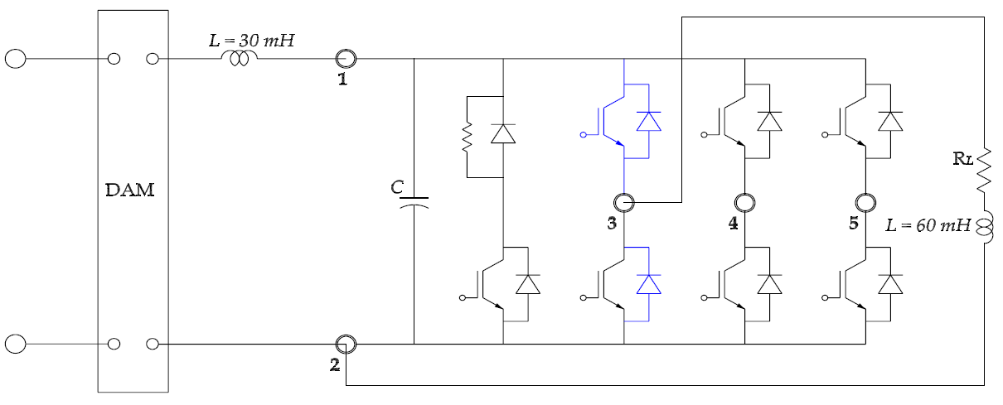

Figure 1:- The figure shows the connection diagram of the Buck DC converter

## 2.1 Experimental Work

This experiment was performed with switching frequency of 12 kHz, and resistive load of 600ohms. We observed and recorded the parameters in section 2.0 for duty cycle of; 0.1, 0.2, 0.3, 0.4, 0.5, 0.6, 0.7, 0.8, and 0.9 respectively; we used a supply voltage of 60V. At D = 0.6, we observed and recorded the waveforms of the input/output currents and voltages as well as their harmonic spectrum. Using the metering feature of DAM and the formula for the efficiency, we completed the table shown below.

|  |  |  |  |  |  |  |  |
| --- | --- | --- | --- | --- | --- | --- | --- |
| D | Pin | Is | Po | Vo | Io | |  | | --- | | η | |
| 0.1 | 1.08 | 0.018 | 0.94 | 26.52 | 0.035 | 87.0370 |
| 0.2 | 2.52 | 0.043 | 2.184 | 39.19 | 0.056 | 86.6667 |
| 0.3 | 3.439 | 0.059 | 3.037 | 45.65 | 0.067 | 88.3106 |
| 0.4 | 3.966 | 0.069 | 3.552 | 49.14 | 0.072 | 89.5613 |
| 0.5 | 4.258 | 0.075 | 3.858 | 51.14 | 0.075 | 90.6059 |
| 0.6 | 4.466 | 0.079 | 4.05 | 52.34 | 0.077 | 90.6852 |
| 0.7 | 4.501 | 0.081 | 4.106 | 52.79 | 0.078 | 91.2242 |
| 0.8 | 4.572 | 0.082 | 4.194 | 53.33 | 0.079 | 91.7323 |
| 0.9 | 4.642 | 0.083 | 4.270 | 53.70 | 0.079 | 91.9862 |

Table 1:- The table shows the data for the buck DC converter with a fixed RL

### 

### 2.1.1 Waveforms of voltages and current at D = 0.6

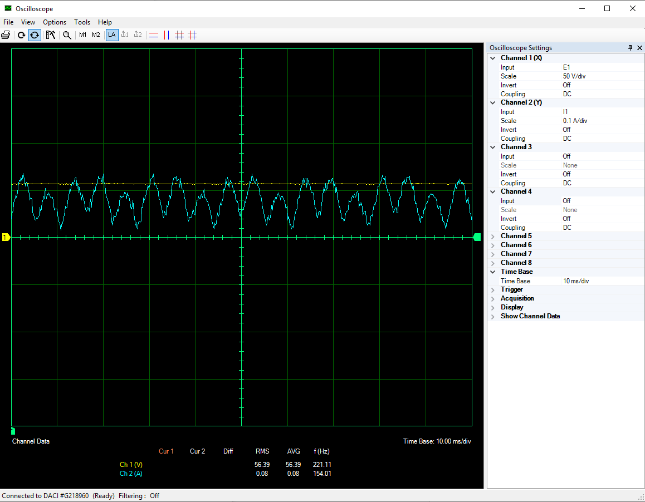

Figure 2:- The figure shows the waveforms of the input voltage and current at D=0.6

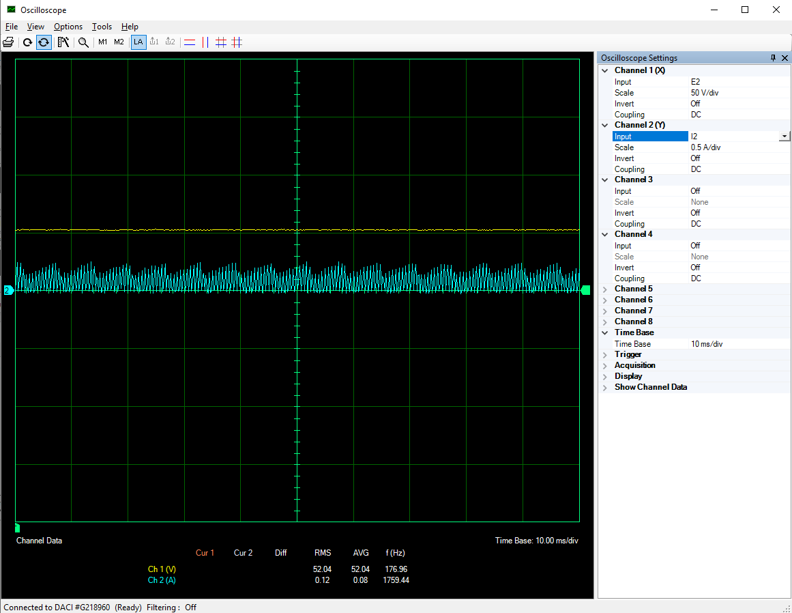

Figure 3:- The figure shows the waveforms of the output voltage and current at D=0.6

### 2.1.2 Harmonic spectrums of the input currents and voltages at D = 0.6

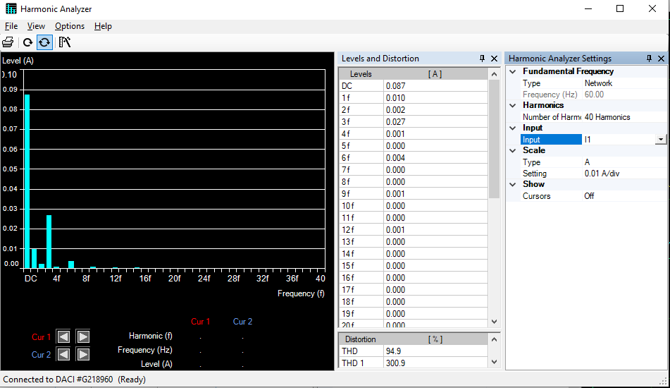

Figure 4:- The figure shows the harmonics of the input current at D = 0.6

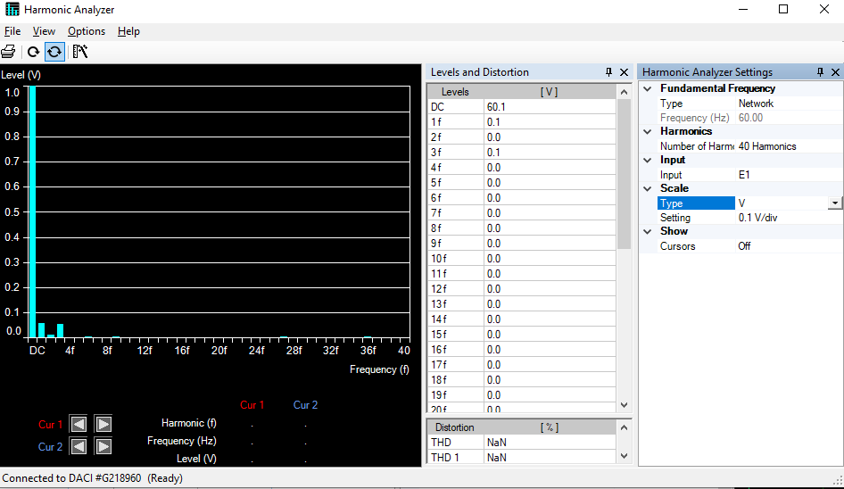

Figure 5:- The figure shows the harmonics of the input voltage at D = 0.6

### 2.1.3 Harmonic spectrums of the output currents and voltages at D = 0.6

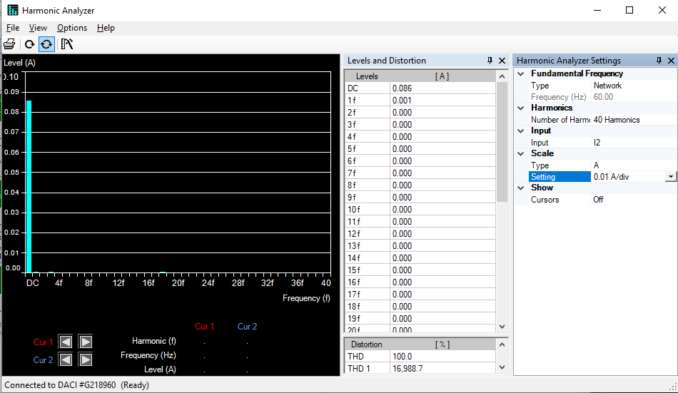

Figure 6:- The figure shows the harmonics of the output current at D = 0.6

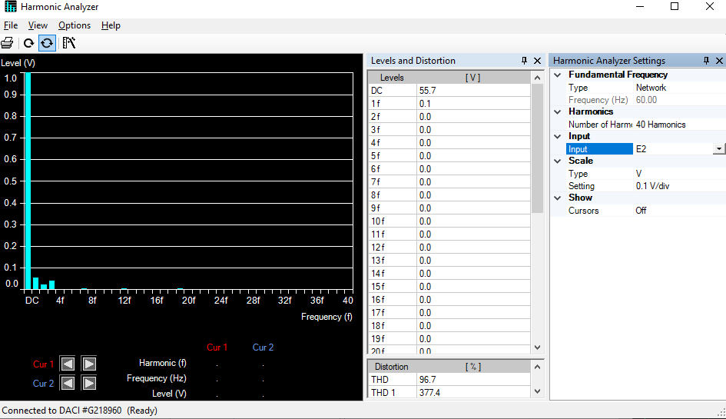

Figure 7:- The figure shows the harmonics of the output voltage at D = 0.6

## 2.2 The Characteristics of the Buck DC Converter

Using the same circuit in section 2.0, this experiment was performed with switching frequency of 8 kHz, and duty cycle of 0.5. We observed and recorded the parameters in section 2.0 for resistive load of; ∞, 1200, 600, 1200||600, 300, 300||1200, 300||600, 300||600||1200 respectively; we used a supply voltage of 100V. At RL = 300ohms, we observed and recorded the waveforms of the input/output currents and voltages as well as their harmonic spectrum. Using the metering feature of DAM and the formula for the efficiency, we completed the table shown below.

|  |  |  |  |  |  |  |  |
| --- | --- | --- | --- | --- | --- | --- | --- |
| RL | Pin | Is | Po | Vo | Io | |  | | --- | | η | |
| ∞ | -0.193 | -0.002 | -0.759 | 100.1 | -0.008 | 0 |
| 1200 | 6.704 | 0.071 | 6.133 | 90.83 | 0.068 | 91.4827 |
| 600 | 12.02 | 0.132 | 11.35 | 85.04 | 0.134 | 94.4260 |
| 1200||600=400 | 16.21 | 0.183 | 15.35 | 80.26 | 0.192 | 94.6946 |
| 300 | 19.93 | 0.228 | 18.64 | 76.04 | 0.245 | 93.5273 |
| 300||1200=240 | 22.74 | 0.265 | 21.14 | 72.41 | 0.292 | 92.9639 |
| 300||600=200 | 25.24 | 0.299 | 23.06 | 69.01 | 0.334 | 91.3629 |
| 300||600||1200=171.43 | 27.43 | 0.328 | 24.98 | 66.36 | 0.376 | 91.0682 |

Table 2:- The table shows the data for the buck DC converter with fixed duty cycle.

### 2.2.1 Waveforms of voltages and current at RL = 300ohms

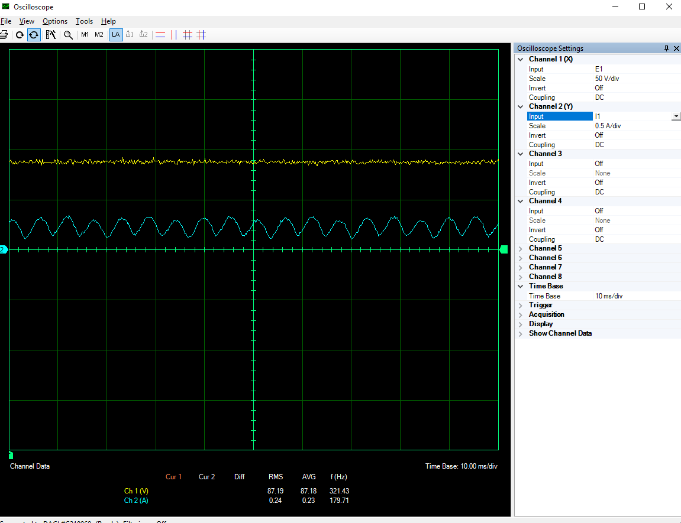

Figure 8:- The figure shows the waveforms of the input voltage and current at RL = 300ohms

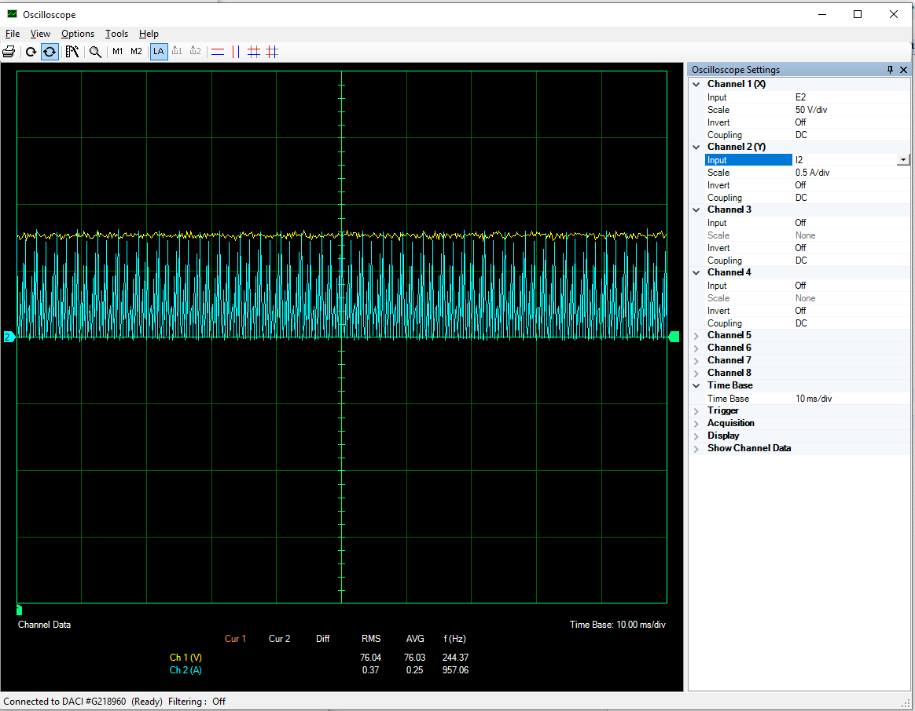

Figure 9:- The figure shows the waveforms of the output voltage and current at RL = 300ohms

### 2.2.2 Harmonic spectrums of the input currents and voltages at RL = 300ohms

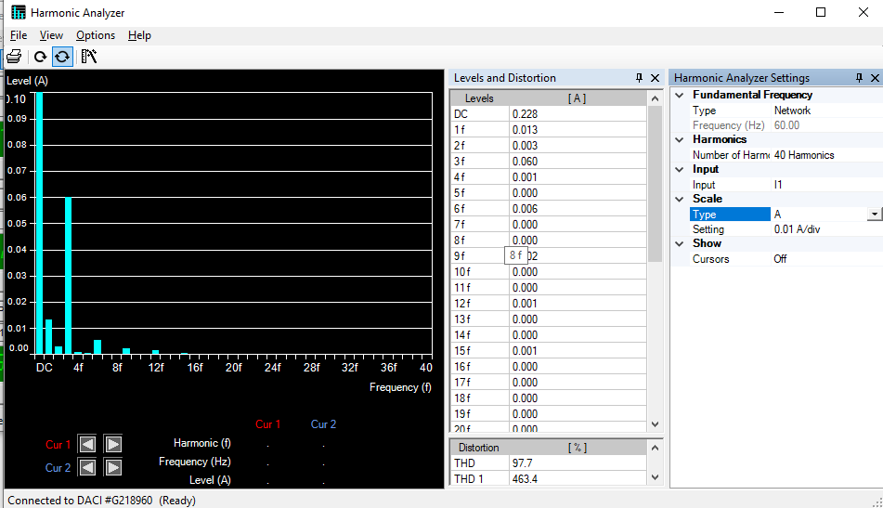

Figure 10:- The figure shows the harmonics of the input current at RL = 300ohms

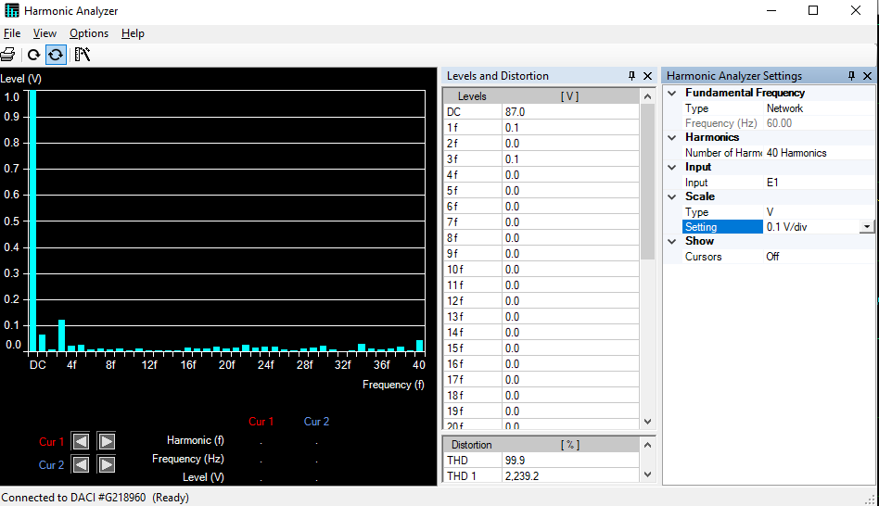

Figure 11:- The figure shows the harmonics of the input voltage at RL = 300ohms

### 2.2.3 Harmonic spectrums of the output currents and voltages at RL = 300ohms

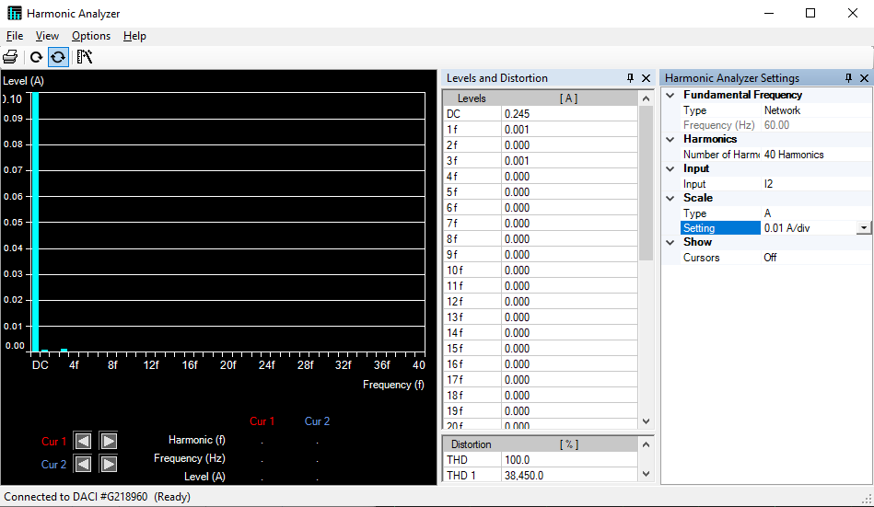

Figure 12:- The figure shows the harmonics of the output current at RL = 300ohms

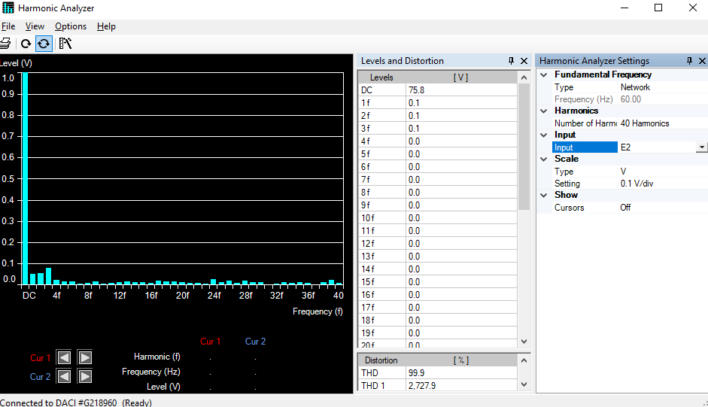

Figure 13:- The figure shows the harmonics of the output voltage at RL = 300ohms

# 3 The Boost Converter

The figure below shows the connection diagram of the Boost DC converter; the Boost DC-DC converter was constructed using the labvolt IGBT chopper/inverter. The switching pulses for the IGBT switch were generated by the Boost Chopper (high-side switching) control feature of the DAM. The data acquisition module (DAM) was used to observe and record; supply voltage, supply current, input active power, output voltage, output current, and output active power.

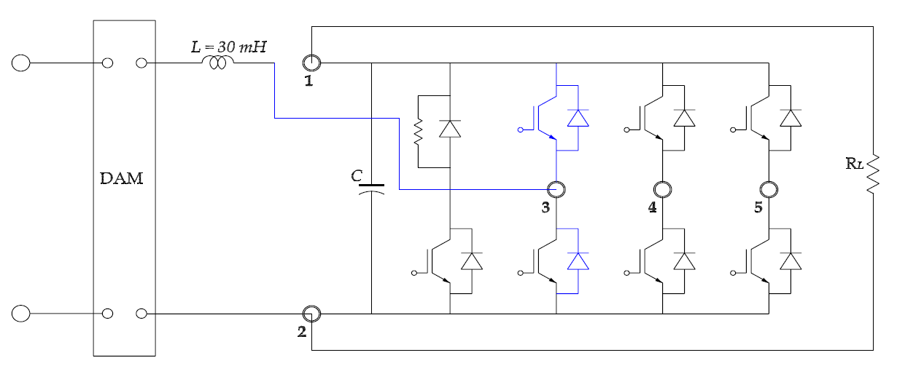

Figure 14:- The figure shows the connection diagram of the Boost DC converter

## 3.1 Experimental Work

This experiment was performed with switching frequency of 18 kHz, and resistive load of 600ohms. We observed and recorded the parameters in section 3.0 for duty cycle of; 0.1, 0.2, 0.3, 0.4, 0.5, 0.6, 0.7, 0.8, and 0.9 respectively; we used a supply voltage of 60V. At D = 0.8, we observed and recorded the waveforms of the input/output currents and voltages as well as their harmonic spectrum. Using the metering feature of DAM and the formula for the efficiency, we completed the table shown below.

|  |  |  |  |  |  |  |  |
| --- | --- | --- | --- | --- | --- | --- | --- |
| D | Pin | Is | Po | Vo | Io | |  | | --- | | η | |
| 0.1 | 7.197 | 0.119 | 6.493 | 65.81 | 0.098 | 90.2181 |
| 0.2 | 8.868 | 0.151 | 7.847 | 72.21 | 0.109 | 88.4867 |
| 0.3 | 11.04 | 0.193 | 9.691 | 79.88 | 0.121 | 87.7808 |
| 0.4 | 14.00 | 0.255 | 12.83 | 90.22 | 0.142 | 91.6429 |
| 0.5 | 19.11 | 0.355 | 17.16 | 103.9 | 0.165 | 89.7959 |
| 0.6 | 28.43 | 0.539 | 25.08 | 125.1 | 0.201 | 88.2167 |
| 0.7 | 48.41 | 0.929 | 41.60 | 160.2 | 0.259 | 85.9327 |
| 0.8 | 94.16 | 1.860 | 74.76 | 213.9 | 0.349 | 79.3968 |
| 0.9 | 194.5 | 4.314 | 121.3 | 267.9 | 0.452 | 62.365 |

Table 3:- The table shows the data for the boost DC converter with a fixed RL

### 3.1.1 Waveforms of voltages and current at D = 0.8

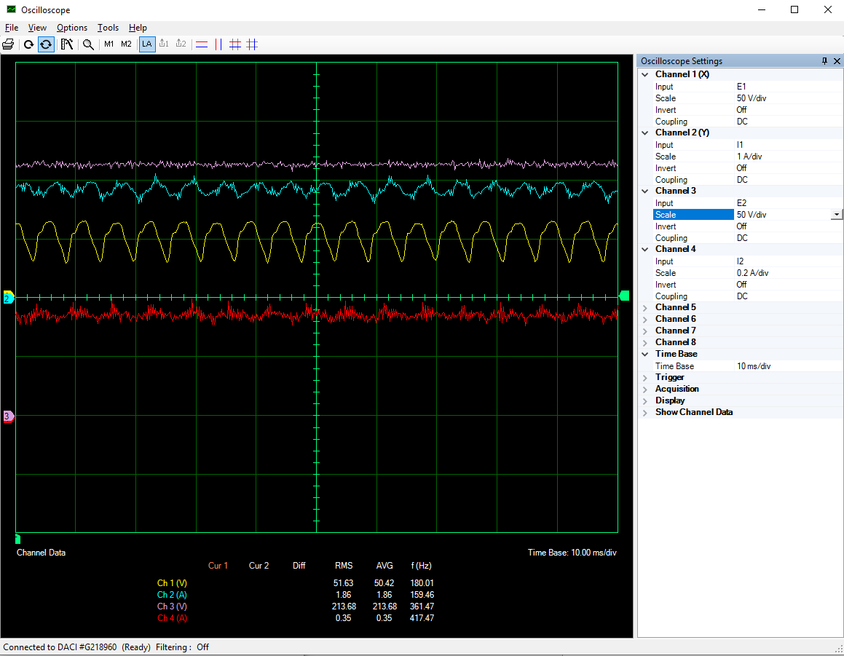

Figure 15:- The figure shows the waveforms of the input/output voltage and current at D=0.8

### 3.1.2 Harmonic spectrums of the input currents and voltages at D = 0.8

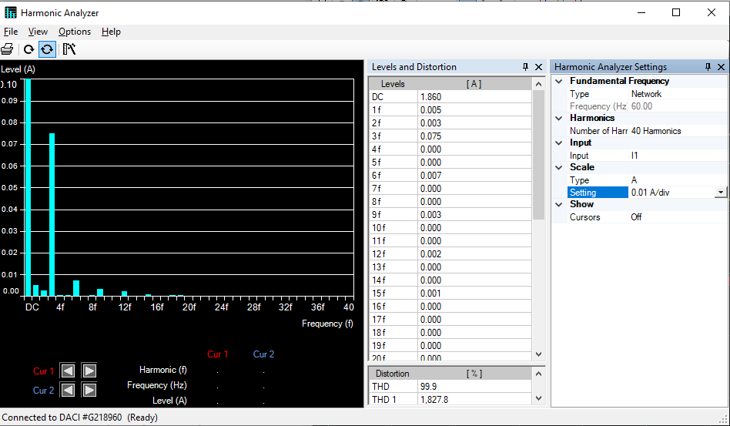

Figure 16:- The figure shows the harmonics of the input current at D = 0.8

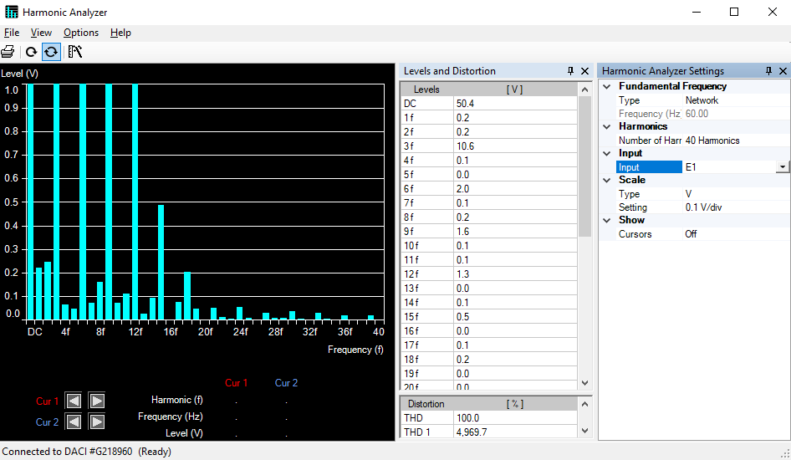

Figure 17:- The figure shows the harmonics of the input voltage at D = 0.8

### 3.1.3 Harmonic spectrums of the output currents and voltages at D = 0.8

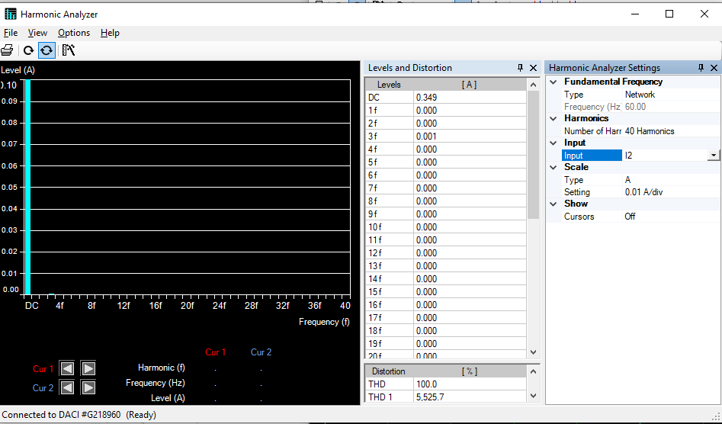

Figure 18:- The figure shows the harmonics of the output current at D = 0.8

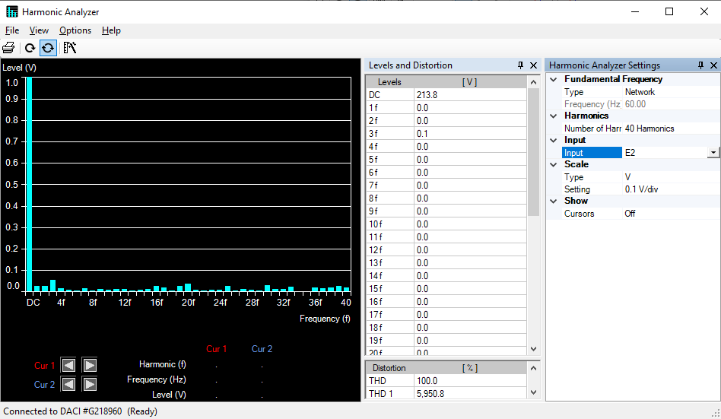

Figure 19:- The figure shows the harmonics of the output voltage at D = 0.8

## 3.2 The Characteristics of the Boost DC Converter

Using the same circuit in section 3.0, this experiment was performed with switching frequency of 12 kHz, and duty cycle of 0.667. We observed and recorded the parameters in section 3.0 for resistive load of; ∞, 1200, 600, 1200||600, 300, 300||1200, 300||600, 300||600||1200 respectively; we used a supply voltage of 50V. At RL = 300ohms, we observed and recorded the waveforms of the input/output currents and voltages as well as their harmonic spectrum. Using the metering feature of DAM and the formula for the efficiency, we completed the table shown below.

|  |  |  |  |  |  |  |  |
| --- | --- | --- | --- | --- | --- | --- | --- |
| RL | Pin | Is | Po | Vo | Io | |  | | --- | | η | |
| ∞ | 0.948 | 0.017 | -1.527 | 172.2 | -0.008 | 0 |
| 1200 | 12.21 | 0.296 | 10.25 | 115.8 | 0.088 | 83.9476 |
| 600 | 22.52 | 0.557 | 19.53 | 110.7 | 0.176 | 86.7229 |
| 1200||600=400 | 31.86 | 0.795 | 27.43 | 106.4 | 0.258 | 86.0954 |
| 300 | 40.41 | 1.023 | 34.42 | 102.7 | 0.335 | 85.1769 |
| 300||1200=240 | 48.27 | 1.233 | 40.39 | 99.49 | 0.406 | 83.6752 |
| 300||600=200 | 55.58 | 1.433 | 45.68 | 96.44 | 0.475 | 82.1878 |
| 300||600||1200=171.43 | 62.28 | 1.618 | 50.16 | 93.43 | 0.537 | 80.5395 |

Table 4:- The table shows the data for the boost DC converter with fixed duty cycle.

### 3.2.1 Waveforms of voltages and current at RL = 300ohms

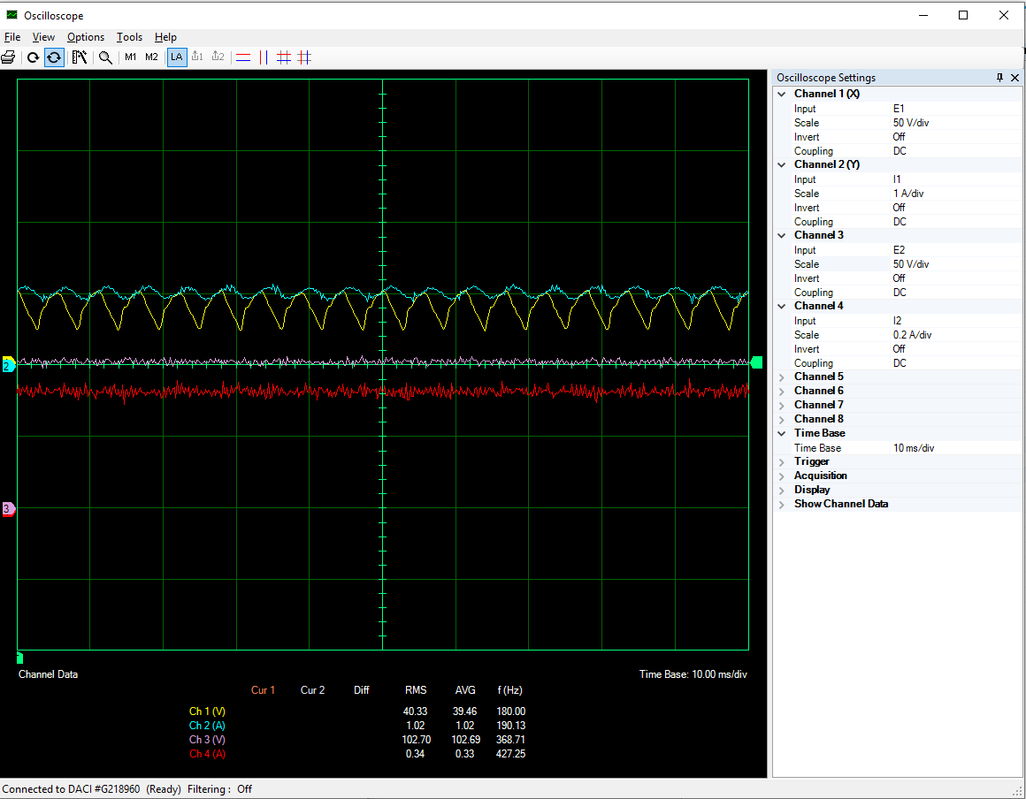

Figure 20:- The figure shows the waveforms of the input/output voltage and current at RL = 300ohms

### 3.2.2 Harmonic spectrums of the input currents and voltages at RL = 300ohms

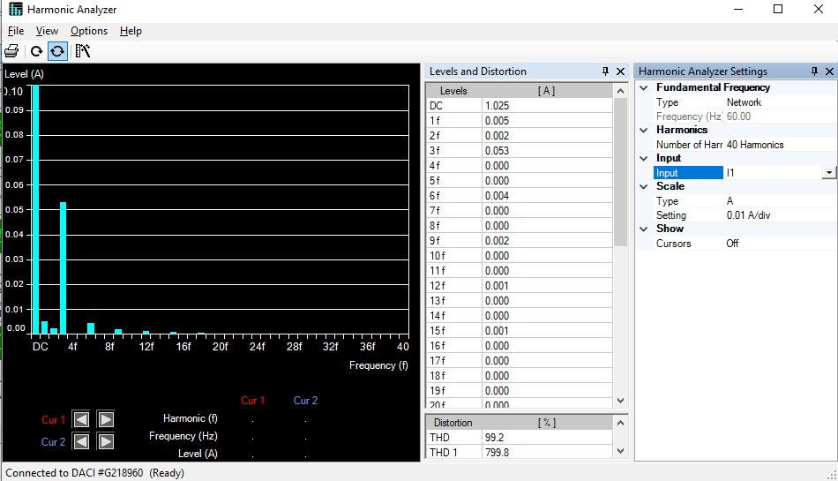

Figure 21:- The figure shows the harmonics of the input current at RL = 300ohms

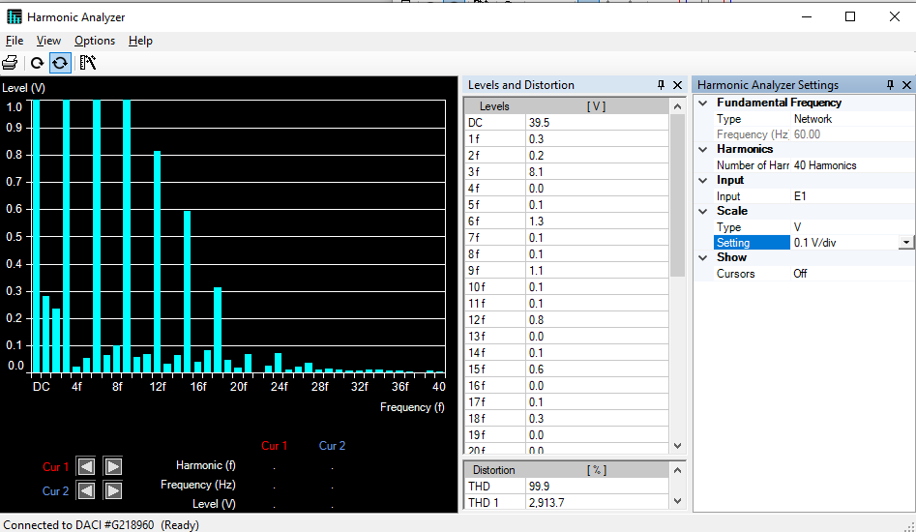

Figure 22:- The figure shows the harmonics of the input voltage at RL = 300ohms

### 3.2.3 Harmonic spectrums of the output currents and voltages at RL = 300ohms

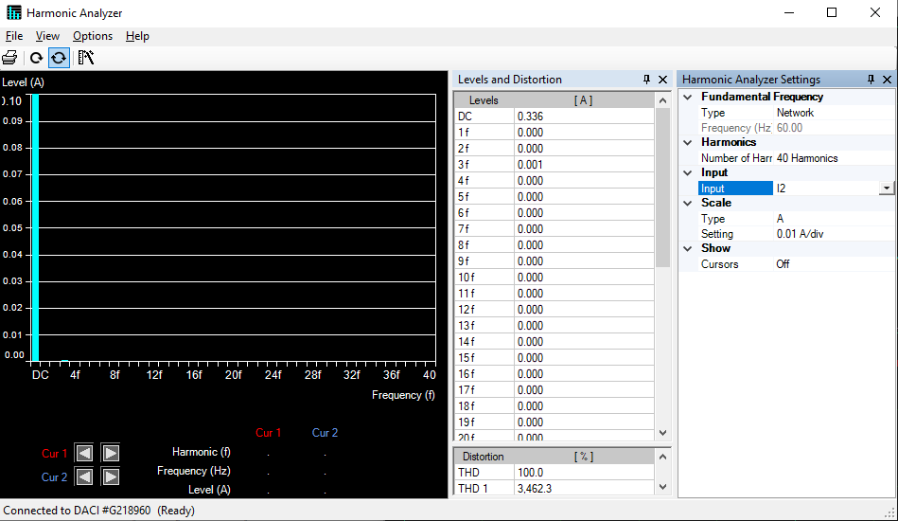

Figure 23:- The figure shows the harmonics of the output current at RL = 300ohms

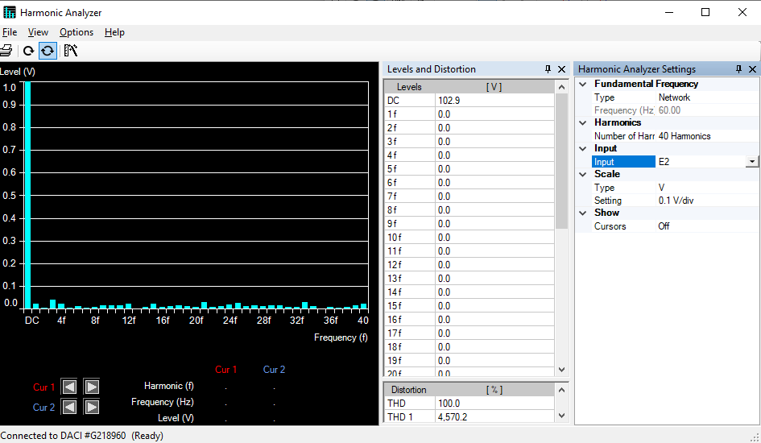

Figure 24:- The figure shows the harmonics of the output voltage at RL = 300ohms

# 4 Calculations and Questions

## **Q1-** Using the data in Table 1, create graphs for D vs Vo, D vs Pin, and D vs η.

Figure 25:- The figure shows a plot between the duty cycle and the output voltage

Figure 26:- The figure shows a plot between the duty cycle and the input active power

Figure 27:- The figure shows a plot between the duty cycle and the efficiency

## Q2 - Using the data in Table 2,create graphs for Io vs Vo, and Io vs η.

Figure 28:- The figure shows a plot between the output current and the output voltage

Figure 29:- The figure shows a plot between the output current and the efficiency

## Q3 - Comment on the graphs created in Q1 and Q2.

Buck converter step-down the output voltage that inductor plays the important role for this purpose. As we can see from the Figure 25, the output voltage has increased by increasing the duty cycle because when we increase D, we allow more voltage transfer from input to output and according to this equation in buck converter VO=D*Vi , the voltage has increased but it cannot be more than our input voltage which is 60V as the D is less than 1 and our circuit is buck converter. Accordingly, by increasing D we are allowing more energy transfer from input to output, so the power has increased, and the efficiency also has increased from 87% to almost 92%.

If we have infinite load, there will be no output current, so it acts like an open circuit. As we decreased the load, the current start increasing slightly but the output voltage will decrease significantly. In addition, by decreasing the load, the output current has increased but the efficiency remains almost the same between the 91% to 94% because both the input and output power has increased.

## Q4 - From the data in Table 3, create graphs for D vs Vo, D vs Pin, and D vs η.

Figure 30:- The figure shows a plot between the duty cycle and the output voltage

Figure 31:- The figure shows a plot between the duty cycle and the input active power

Figure 32:- The figure shows a plot between the duty cycle and the efficiency

## Q5 - Using the data in Table 4,create graphs for Io vs Vo, and Io vs η.

Figure 33:- The figure shows a plot between the output current and the output voltage

Figure 34:- The figure shows a plot between the output current and the efficiency

## Q6 - Comment on the graphs created in Q4 and Q5.

Boost converter step-up the output voltage. By increasing the duty cycle (D), according to the topology of boost converter and this equation VO=Vi/ (1-D), the output voltage has increased therefore the more energy and power will transfer to the output but we should notice that as we increase the output voltage (by increasing D) the efficiency is almost the same until it reaches D=0.8 and after that because of losses in switching elements and non-linear characteristics, the efficiency has decreased drastically. Furthermore, by decreasing the load, the output voltage has decreased significantly in compare to the slightly increase in the current. Also, the output and input power will increased because the input and output current have increased, therefore the efficiency remains almost the same.

# 5 Conclusions

We have done experiments on two dc-dc converters. In buck converter the output voltage is directly proportional to the duty cycle (D) and the input voltage by this equation VO=D*Vi. Therefore, as we expected, by increasing the D output voltage will be increased but it can not be the same as input voltage because the D is less that 1. Also, in buck converter we have higher efficiency for high value of D.

In the boost converter the output voltage increases by increasing the D but the efficiency will decrease particularly when we have D>0.8 because we have more losses in our switching elements and more currents which leads to heating.